Christine Conklin
CS311 – Artificial Intelligence
Natural Gas Application

- Name and Purpose of the Application
  - Application Name: Natural Gas Price Prediction (natural_gas_predictor.py)
  - Purpose: This application predicts the next-day closing price of natural gas futures using historical market data. The goal is to assist traders, analysts and financial planners in making informed decisions based on machine learning forecasts. The system leverages historical price trends, volatility measures and moving averages to model short-term price behavior.
- Algorithms Used
  - The application uses Random Forest Regression, an ensemble machine learning algorithm that builds multiple decision trees and averages their predictions.
  - Random Forest was selected because:
    - It handles nonlinear financial data effectively
    - It reduces overfitting compared to single decision trees
    - It performs well with volatile and noisy datasets
    - It requires minimal feature scaling
- Dataset Information
  - Dataset Source
    - Yahoo Finance – Natural Gas Futures (Ticker: NG=F)
      - https://finance.yahoo.com/quote/NG=F
  - Number of Records
    - Approximately 3,500-4,000 daily observations(2010-2024)
  - Feature Description -note: The model uses Open, High, Low, Volume, MA_7, MA_30, Volatility and Return as input features. Target Close is used to compute engineered features and the next=day target.
Feature | Description | Data Type
Open | Open Price | Float
High | Daily Highest Price | Float
Low | Daily Lowest Price | Float
Close | Daily Closing Price | Float
Volume | Trading Volume | Integer
MA_7 | 7-Day Moving Average | Float
MA_30 | 30-Day Moving Average | Float
Volatility | 7-Day Rolling Standard Deviation | Float
Return | Daily Percentage Return | Float
Target | Next Day Closing Price | Float
  - Preprocessing Steps
    - Converted date column to datetime
    - Sorted by chronological order
    - Created moving averages
    - Calculated rolling volatility
    - Generated daily returns
    - Removed missing values
    - Shifted closing price to create prediction target
- Libraries, Toolkits, and Frameworks
Library | Purpose
Pandas | Data manipulation
NumPy | Numerical operations
Scikit-learn | Machine learning algorithms
Matplotlib | Data visualization
Seaborn | Statistical plotting
yfinance | Data extraction
- Application Design and Implementation
  - Download historical natural gas price data
  - Perform feature engineering
  - Split data into training and testing sets
  - Train Random Forest model
  - Generate predictions
  - Evaluate using RMSE and R²
  - Plot predicted vs actual prices
- Instructions for Running the App
  - Install required libraries: pip install pandas numpy matplotlib seaborn scikit-learn yfinance
    - Windows: python -m pip install pandas numpy matplotlib seaborn scikit-learn yfinance
  - Save file as natural_gas_predictor.py
  - Run: python natural_gas_predictor.py
- Results
  - The model outputs:
    - RMSE score 1.0957
    - R² score 0.6993
    - Line chart comparing predicted and actual prices
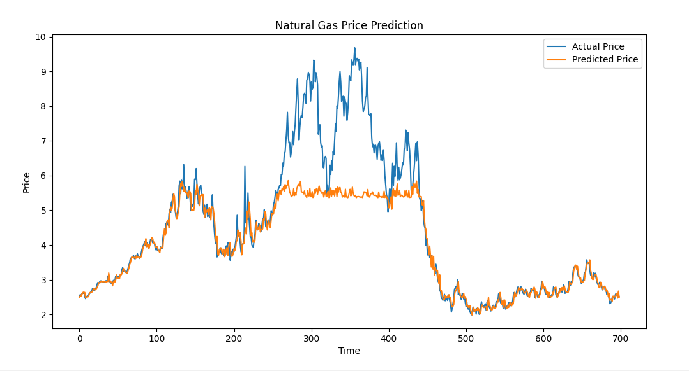

- Discussion and Insights
  - Natural gas prices exhibit high volatility and seasonality due to weather demand, geopolitical events, and supply fluctuations. While Random Forest captures nonlinear patterns effectively, limitations include:
    - No macroeconomic indicators included
    - No seasonality decomposition
    - Limited long-term forecasting ability
    - Market shocks remain unpredictable.
  - Future improvements:
    - Add weather data
    - Include macroeconomic indicators(inflation, USD index)
    - Implement LSTM neural networks for time series modeling
    - Hyperparameter tuning
- References
  - Energy Information Administration. (2023). Natural gas explained. U.S. Department of Energy. https://www.eia.gov/energyexplained/natural-gas/
  - Yahoo Finance. (2024). Natural Gas Futures Historical Data (NG=F). https://finance.yahoo.com/quote/NG=F
  - Breiman, L. (2001). Random forests. Machine Learning, 45(1), 5–32. https://doi.org/10.1023/A:1010933404324

